**Requirement Summary**

* We need to record the term life(TL) and whole life(WL) premium prices of various companies mentioned in our template on a monthly basis from the compare first website:  [http://www.comparefirst.sg](http://www.comparefirst.sg/)
* In order to extract the required data, we need to select the relevant parameters and then sort company names from (A-Z).
* Each sheet is set up for a particular quote, eg. male/female, age, product features. We enter these details into the comparefirst.sg website and get a quote from each company. Below are the categories that we need to work on:
* TL 20Y 45M
* TL 20Y 45F
* TL 5Y 45M
* TL 5Y 45F
* TL 20Y 30M
* TL 20Y 30F
* TL 20Y 45M CI
* WL 25P 45M
* WL 25P 45M (2)
* WL 25P 45F
* WL 40P 30M
* WL 40P 30F
* WL 40P 45M
* WL 25P 45M CI

**Requirement document**

[http://www.comparefirst.sg/wap/homeEvent.action#](http://www.comparefirst.sg/wap/homeEvent.action)

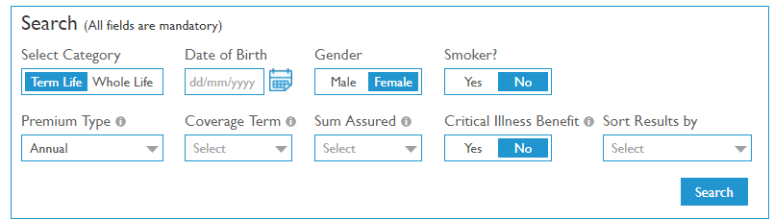

Update values as below

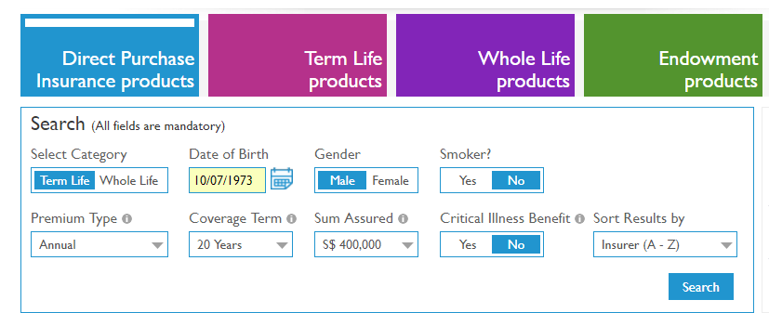

Click on Agreed (pop up window)

Extract preimum data as below

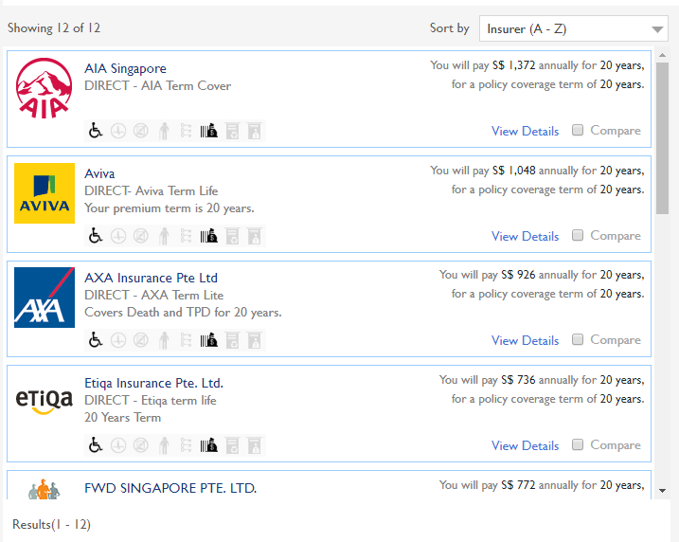

Table details (historical records)

|  |  |  |  |  |  |  |  |  |  |  |  |  |  |  |  |  |  |
| --- | --- | --- | --- | --- | --- | --- | --- | --- | --- | --- | --- | --- | --- | --- | --- | --- | --- |
| **PRICE QUOTES: Term Life** | | |  |  |  |  |  |  |  |  |  |  |  |  |  |  |  |
| Source: | [http://www.comparefirst.sg](http://www.comparefirst.sg/) | |  |  |  |  |  |  |  |  |  |  |  |  |  |  |  |
|  |  |  |  |  |  |  |  |  |  |  |  |  |  |  |  |  |  |
|  | **Annual premium (S$)** | **AIA** | **Aviva** | **AXA** | **Etiqa** | **FWD** | **GE** | **HSBC** | **MFC** | **NTUC** | **PRU** | **Tokio Marine** | **Zurich** |  | **AVG** | **since inception** | |
|  | Age at purchase | 45 | 45 | 45 | 45 | 45 | 45 | 45 | 45 | 45 | 45 | 45 | 45 |  |  |  |  |
|  | Sex | Male | Male | Male | Male | Male | Male | Male | Male | Male | Male | Male | Male |  |  |  |  |
|  | Smoker? | No | No | No | No | No | No | No | No | No | No | No | No |  |  |  |  |
|  | Sum insured (S$) | 4,00,000 | 4,00,000 | 4,00,000 | 4,00,000 | 4,00,000 | 4,00,000 | 4,00,000 | 4,00,000 | 4,00,000 | 4,00,000 | 4,00,000 | 4,00,000 |  |  |  |  |
|  | Interest rate |  |  |  |  |  |  |  |  |  |  |  |  |  |  |  |  |
|  | SI features | Level | Level | Level | Level | Level | Level | Level | Level | Level | Level | Level | Level |  |  |  |  |
|  | Policy term (years) | 20 | 20 | 20 | 20 | 20 | 20 | 20 | 20 | 20 | 20 | 20 | 20 |  |  |  |  |
|  | Premium term | 20 | 20 | 20 | 20 | 20 | 20 | 20 | 20 | 20 | 20 | 20 | 20 |  |  |  |  |
|  | Death cover? | Yes | Yes | Yes | Yes | Yes | Yes | Yes | Yes | Yes | Yes | Yes | Yes |  |  |  |  |
|  | Terminal illness? | Yes | Yes | Yes | Yes | Yes | Yes | Yes | Yes | Yes | Yes | Yes | Yes |  |  |  |  |
|  | TPD? | Yes | Yes | Yes | Yes | Yes | Yes | Yes | Yes | Yes | Yes | Yes | Yes |  |  |  |  |
|  | Critical illness? | No | No | No | No | No | No | No | No | No | No | No | No |  |  |  |  |
|  | Other benefits? | No | No | No | No | No | No | No | No | No | No | No | No |  |  |  |  |
|  | Par or Non-par? | Non-par | Non-par | Non-par | Non-par | Non-par | Non-par | Non-par | Non-par | Non-par | Non-par | Non-par | Non-par |  |  |  |  |
|  | Renewability | No | No | No | No | No | No | No | No | No | No | No | No |  |  |  |  |
|  |  |  |  |  |  |  |  |  |  |  |  |  |  |  |  |  |  |
|  | Apr-15 | 1,830 | 1,445 | 1,016 | 1,310 |  | 1,608 | 1,313 | 1,455 | 1,439 | 1,520 | 1,222 | 1,503 |  | 1,424 |  |  |
|  | May-15 | 1,830 | 1,445 | 1,016 | 1,431 |  | 1,608 | 1,563 | 1,455 | 1,293 | 1,696 | 1,222 | 1,503 |  | 1,460 | 2.6% |  |
|  | Jun-15 | 1,830 | 1,445 | 1,016 | 1,431 |  | 1,608 | 1,563 | 1,455 | 1,293 | 1,696 | 1,222 | 1,503 |  | 1,460 | 2.6% |  |
|  | Jul-15 | 1,372 | 1,445 | 1,016 | 1,431 |  | 1,608 | 1,563 | 1,455 | 1,293 | 1,696 | 1,222 | 1,503 |  | 1,419 | -0.4% |  |
|  | Aug-15 | 1,372 | 1,445 | 1,016 | 1,431 |  | 1,608 | 1,563 | 1,455 | 1,293 | 1,696 | 1,222 | 1,503 |  | 1,419 | -0.4% |  |
|  | Sep-15 | 1,372 | 1,445 | 1,016 | 1,431 |  | 1,608 | 1,312 | 1,455 | 1,293 | 1,696 | 1,222 |  |  | 1,385 | -2.7% |  |
|  | Oct-15 | 1,372 | 1,445 | 1,016 | 1,431 |  | 1,608 | 1,312 | 1,455 | 1,293 | 1,696 | 1,222 |  |  | 1,385 | -2.7% |  |
|  | Nov-15 | 1,372 | 1,445 | 1,016 | 1,431 |  | 1,608 | 1,312 | 1,455 | 1,293 | 1,696 | 1,222 |  |  | 1,385 | -2.7% |  |
|  | Dec-15 | 1,372 | 1,445 | 1,016 | 1,431 |  | 1,608 | 1,312 | 1,455 | 1,293 | 1,696 | 1,222 |  |  | 1,385 | -2.7% |  |
|  | Jan-16 | 1,372 | 1,445 | 1,016 | 1,431 |  | 1,608 | 1,312 | 1,455 | 1,293 | 1,696 | 1,222 |  |  | 1,385 | -2.7% |  |
|  | Feb-16 | 1,372 | 1,445 | 1,016 | 1,431 |  | 1,608 | 1,312 | 1,455 | 1,293 | 1,696 | 1,222 |  |  | 1,385 | -2.7% |  |
|  | Mar-16 | 1,372 | 1,445 | 1,016 | 1,431 |  | 1,608 | 1,312 | 1,455 | 1,293 | 1,696 | 1,222 |  |  | 1,385 | -2.7% |  |
|  | Apr-16 | 1,372 | 1,445 | 1,016 | 1,431 |  | 1,000 | 1,312 | 1,455 | 1,293 | 1,696 | 1,222 |  |  | 1,324 | -7.0% |  |
|  | May-16 | 1,372 | 1,445 | 1,016 | 1,431 |  | 1,000 | 1,312 | 1,455 | 1,293 | 1,696 | 1,222 |  |  | 1,324 | -7.0% |  |
|  | Jun-16 | 1,372 | 1,445 | 1,016 | 1,431 |  | 1,000 | 1,312 | 1,455 | 1,293 | 1,696 | 1,222 |  |  | 1,324 | -7.0% |  |
|  | Jul-16 | 1,372 | 1,445 | 1,016 | 1,431 |  | 1,000 | 1,312 | 1,455 | 1,293 | 1,696 | 1,222 |  |  | 1,324 | -7.0% |  |
|  | Aug-16 | 1,372 | 1,445 | 1,016 | 1,431 |  | 1,000 | 1,312 | 1,455 | 1,293 | 1,696 | 1,222 |  |  | 1,324 | -7.0% |  |
|  | Sep-16 | 1,372 | 1,445 | 926 | 1,431 | 948 | 1,000 | 1,312 | 1,455 | 1,093 | 1,696 | 1,222 |  |  | 1,264 | -11.2% |  |
|  | Oct-16 | 1,372 | 1,445 | 926 | 1,431 | 948 | 1,000 | 1,312 | 1,455 | 1,093 | 1,696 | 1,222 |  |  | 1,264 | -11.2% |  |
|  | Nov-16 | 1,372 | 1,445 | 926 | 1,431 | 948 | 1,000 | 1,312 | 1,455 | 1,093 | 1,696 | 1,222 |  |  | 1,264 | -11.2% |  |
|  | Dec-16 | 1,372 | 1,445 | 926 | 1,431 | 948 | 1,000 | 1,312 | 1,455 | 1,093 | 1,696 | 1,222 |  |  | 1,264 | -11.2% |  |
|  | Jan-17 | 1,372 | 1,048 | 926 | 1,431 | 948 | 1,000 | 1,312 | 1,399 | 1,005 | 1,696 | 1,222 |  |  | 1,214 | -14.7% |  |
|  | Feb-17 | 1,372 | 1,048 | 926 | 1,431 | 948 | 1,000 | 1,312 | 1,399 | 1,005 | 1,696 | 1,222 |  |  | 1,214 | -14.7% |  |
|  | Mar-17 | 1,372 | 1,048 | 926 | 1,431 | 948 | 1,000 | 1,312 | 1,399 | 1,005 | 1,696 | 1,222 |  |  | 1,214 | -14.7% |  |
|  | Apr-17 |  |  |  |  |  |  |  |  |  |  |  |  |  |  |  |  |
|  | May-17 |  |  |  |  |  |  |  |  |  |  |  |  |  |  |  |  |
|  | Jun-17 |  |  |  |  |  |  |  |  |  |  |  |  |  |  |  |  |
|  | Jul-17 |  |  |  |  |  |  |  |  |  |  |  |  |  |  |  |  |
|  | Aug-17 |  |  |  |  |  |  |  |  |  |  |  |  |  |  |  |  |
|  | Sep-17 |  |  |  |  |  |  |  |  |  |  |  |  |  |  |  |  |
|  | Oct-17 |  |  |  |  |  |  |  |  |  |  |  |  |  |  |  |  |
|  | Nov-17 |  |  |  |  |  |  |  |  |  |  |  |  |  |  |  |  |
|  | Dec-17 |  |  |  |  |  |  |  |  |  |  |  |  |  |  |  |  |
|  | Jan-18 | 1,372 | 1,048 | 926 | 1,310 | 948 | 1,000 | 1,204 | 1,399 | 1,005 | 1,520 | 772 |  |  | 1,137 | -20.2% |  |
|  | Feb-18 | 1,372 | 1,048 | 926 | 1,431 | 948 | 1,000 | 1,312 | 1,399 | 1,005 | 1,696 | 772 |  |  | 1,174 | -17.6% |  |
|  | Mar-18 | 1,372 | 1,048 | 926 | 1,310 | 948 | 1,000 | 1,204 | 1,399 | 1,005 | 1,520 | 772 |  |  | 1,137 | -20.2% |  |
|  | Apr-18 | 1,372 | 1,048 | 926 | 1,431 | 772 | 1,000 | 1,312 | 1,399 | 1,005 | 1,696 | 772 |  |  | 1,158 | -18.7% |  |
|  | May-18 | 1,372 | 1,048 | 926 | 804 | 772 | 1,000 | 1,036 | 1,399 | 1,005 | 1,696 | 772 |  |  | 1,075 | -24.5% |  |
|  | Jun-18 | 1,372 | 1,048 | 926 | 804 | 772 | 1,000 | 1,036 | 1,399 | 1,005 | 1,696 | 772 |  |  | 1,075 | -24.5% |  |
|  |  |  |  |  |  |  |  |  |  |  |  |  |  |  |  |  |  |
|  |  |  |  |  |  |  |  |  |  |  |  |  |  |  |  |  |  |